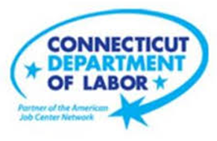

**NEW WEEKLY JOB POSTINGS FROM   
HELP WANTED ONLINE  
Office of Research**

**Week Ending December 31st, 2022: Total New Ads Fall During Week Before New Year’s Day.**WETHERSFIELD, January 6th, 2022 – During the week ending December 31st, there were 3,726 new postings, down ‑2,460 or ‑40% over the week. This over-the-week drop before New Year’s Eve during the last week of December 2022 echoes the 37% drop experienced a year ago during the last week of December 2021. Two years ago during the last week of December 2020, total ads were down 15% and subsequently down -27% during the first week of January 2021. Four industries accounted for more than half of the drop during the week ending December 31st, 2022. These include Healthcare & Social Assistance (-456 new ads), Finance & Insurance (-351 new ads), Manufacturing (-280 new ads), and Educational Services (-216 new ads). Employers with the largest over-the-week drops include Hartford Healthcare (-181 new ads), Trinity Health (-98 new ads), Raytheon (-80 new ads), and Walmart/Sam’s (-65 new ads). The graph below shows how new ads typically slow around the start of the year. This recent week of new job ads is the lowest level since the week ending January 2nd, 2021, which had a similar New Year’s drop to 2,413 new ads.   
  
  
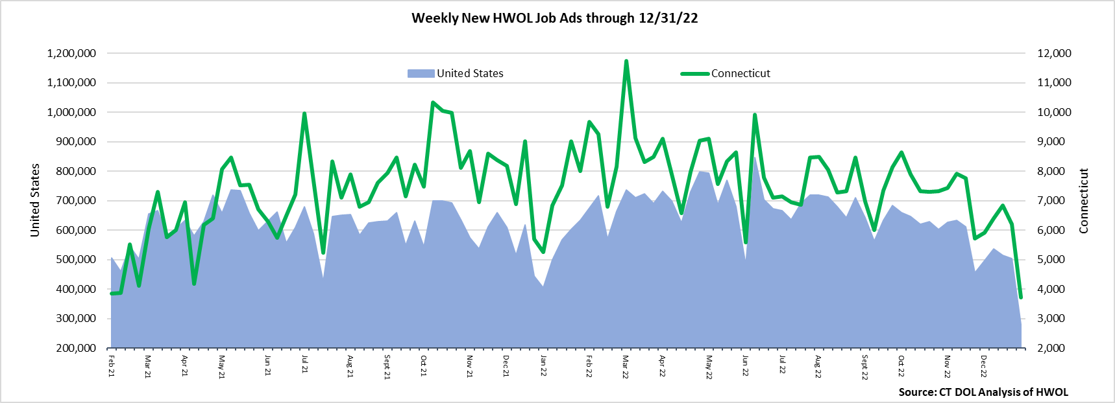  
**Industries** with the most new postings include Health Care & Social Assistance, Retail Trade, and Finance & Insurance.

**Occupations** with the most new postings include Registered Nurses, Retail Salespersons, and Wholesale & Manufacturing Sales Representatives.

**Employers** with the most new postings include Community Health Center, Inc., Yale-New Haven Health System, and KPMG.

**The three industries with the most new job postings were:**

* **Health Care & Social Assistance** (1,169 new postings, -28% over the week)
* **Retail Trade** (352 new postings, -37% over the week)
* **Finance & Insurance** (246 new postings, -59% over the week)

   
 During the week ending December 31st, 2022, the 40% new ad total decrease is the net result of decreases in every industry other than Agriculture, which had a slight increase. Decreasing industries were down between -22% (Accommodation & Food Services) and -69% (Information). The largest over-the-week employer declines among the four industries with the largest declines include Hartford Healthcare (-181 new ads) in Health Care & Social Assitance, Cigna (-52 new ads) in Finance & Insurance, Raytheon (-80 new ads) in manufacturing, and University of Connecticut (‑23 new ads) in Educational Services. Over four weeks, every industry except for Agriculture was down between -25% to -79%.   
  
 For more information on total job ads by industry for Connecticut and its labor market areas, see the monthly report available here: <https://www1.ctdol.state.ct.us/lmi/hwol.asp>

**New Job Postings by Occupation** 

**The occupations with the most new postings were:**

* Registered Nurses (303 new postings, -30% over the week)
* Retail Salespersons (128 new postings, +22% over the week)
* Supervisors of Retail Sales Workers (94 new postings, -25% over the week)

**Employers with the Most New Job Postings** Employers with the most new job postings during the week were mostly within Health Care & Social Assistance, Retail Trade, and Manufacturing. The 25 employers shown above account for 23 percent of all new ads. 13 of 25 employers in the top 25 increased over the week and 12 decreased. Within the 25 largest employers, the largest decrease occurred ad Hartford Healthcare (-181 new ads) and the largest increase occurred at Community Health Center, Inc. (+115 new ads).  
  
**What is HWOL?**The **Conference Board Help Wanted Online**® Data Series (HWOL) measures the number of new, first-time Online job postings and jobs reposted from the previous month for over 16,000 Internet job boards, corporate boards, and smaller job sites that serve niche markets and smaller geographic areas. To view more HWOL data, go to: <https://www1.ctdol.state.ct.us/lmi/hwol.asp>